NGEH CLOVIS NGINYU

INTERN AT SKYE8

NETWORK & SECURITY AND CYBER SECURITY

PROJECT

Network Analysis

In order to measure the strength if a network, network engineers must be able to access some specific network tools and analysis the various packets in a network. Some of those tools are:

1. **Wireshark,**
2. **Negios,**
3. **Tcpdump,**
4. **SolarWinds,**
5. **Netminer and more.**

Choose three of these netwoking tools study them and install atleast 2 unto your device and produce a document that explain how to use them and give some examples which you have tried.

In this task I shall expand more on **wireshark, Netminer & Tcpdump** explaining how to install on other operating systems and real time examples of the effective running of these tools.

1. **WIRESHARK**

**What Is Wireshark?**

Wireshark is a network protocol analyzer, or an application that captures packets from a network connection, such as from your computer to your home office or the internet. Packet is the name given to a discrete unit of data in a typical Ethernet network.

Wireshark is the most often-used packet sniffer in the world. Like any other packet sniffer, Wireshark does three things:

1. **Packet Capture:** Wireshark listens to a network connection in real time and then grabs entire streams of traffic – quite possibly tens of thousands of packets at a time.
2. **Filtering:** Wireshark is capable of slicing and dicing all of this random live data using filters. By applying a filter, you can obtain just the information you need to see.
3. **Visualization:** Wireshark, like any good packet sniffer, allows you to dive right into the very middle of a network packet. It also allows you to visualize entire conversations and network streams.

Packet sniffing can be compared to spelunking – going inside a cave and hiking around. Folks who use Wireshark on a network are kind of like those who use flashlights to see what cool things they can find. After all, when using Wireshark on a network connection (or a flashlight in a cave), you’re effectively using a tool to hunt around tunnels and tubes to see what you can see.

## What Is Wireshark Used For?

Wireshark has many uses, including [troubleshooting networks](https://www.comptia.org/content/guides/a-guide-to-network-troubleshooting) that have performance issues. Cybersecurity professionals often use Wireshark to trace connections, view the contents of suspect network transactions and identify bursts of network traffic. It’s a major part of any IT pro’s toolkit – and hopefully, the IT pro has the knowledge to use it.

## Common Wireshark Use Cases

Here’s a common example of how a Wireshark capture can assist in identifying a problem.

Wireshark is often used to identify more complex network issues. For example, if a network experiences too many retransmissions, congestion can occur. By using Wireshark, you can identify specific retransmission issues

## How to Use Wireshark

You can download Wireshark for free at [www.wireshark.org](https://www.wireshark.org/). It’s also freely available, as an open source application under the [GNU General Public License](https://www.gnu.org/licenses/old-licenses/gpl-2.0.en.html) version 2.

### How to Install Wireshark on Windows

If you’re a Windows operating system user, download the version appropriate for your particular version. If you use Windows 10, for example, you’d grab the 64-bit Windows installer and follow the wizard to install. To install, you’ll need administrator permissions.

### How to Install Wireshark on Linux

If you have a [Linux system](https://www.comptia.org/blog/all-about-linux-and-linux), you’d install Wireshark using the following sequence (notice that you’ll need to have root permissions):

***$ sudo apt-get install wireshark***

***$ sudo dpkg-reconfigure wireshark-common***

***$ sudo usermod -a -G wireshark $USER***

***$ newgrp wireshark***

Once you have completed the above steps, you then log out and log back in, and then start Wireshark:

***$ wireshark &***

### **How to Capture Packets Using Wireshark**

Once you’ve installed Wireshark, you can start grabbing network traffic. But remember: To capture any packets, you need to have proper permissions on your computer to put Wireshark into promiscuous mode.

* + In a Windows system, this usually means you have administrator access.
  + In a Linux system, it usually means that you have root access.

This window will list all available interfaces. In this case, Wireshark provides several to choose from. Wireshark visualizes the traffic by showing a moving line, which represents the packets on the network.

Once the network interface is selected, you simply click the Start button to begin your capture. As the capture begins, it’s possible to view the packets that appear on the screen

Once you have captured all the packets that you want, simply click the red, square button at the top. Now you have a static packet capture to investigate.

### What the Color Coding Means in Wireshark

Now that you have some packets, it’s time to figure out what they mean. Wireshark tries to help you identify packet types by applying common-sense color coding. The table below describes the default colors given to major packet types.

|  |
| --- |
| **Color in Wireshark** | **Packet Type** |
| Light purple | TCP |
| Light blue | UDP |
| Black | Packets with errors |
| Light green | HTTP traffic |
| Light yellow | Windows-specific traffic, including Server Message Blocks (SMB) and NetBIOS |
| Dark yellow | Routing |
| Dark gray | TCP SYN, FIN and ACK traffic |

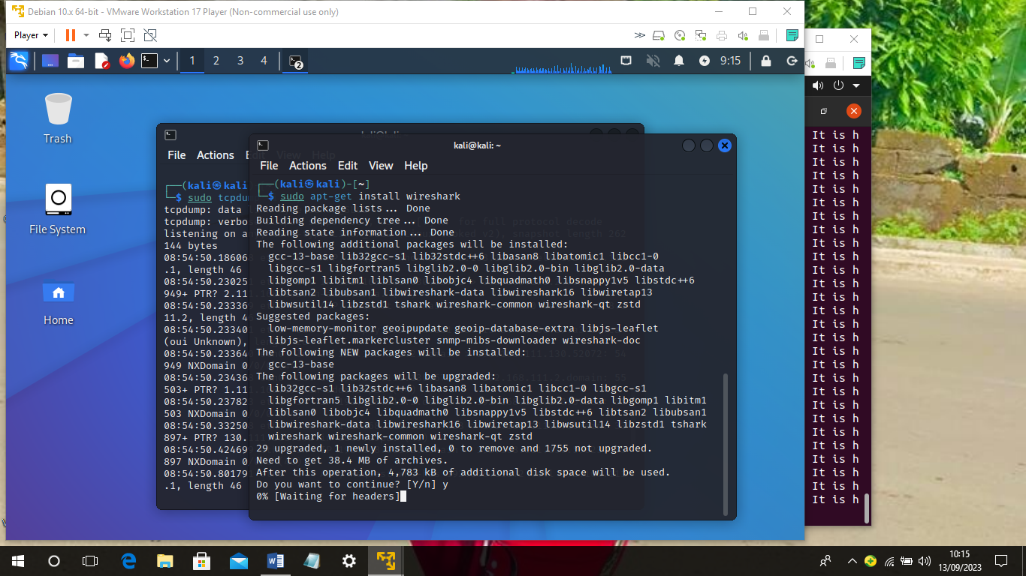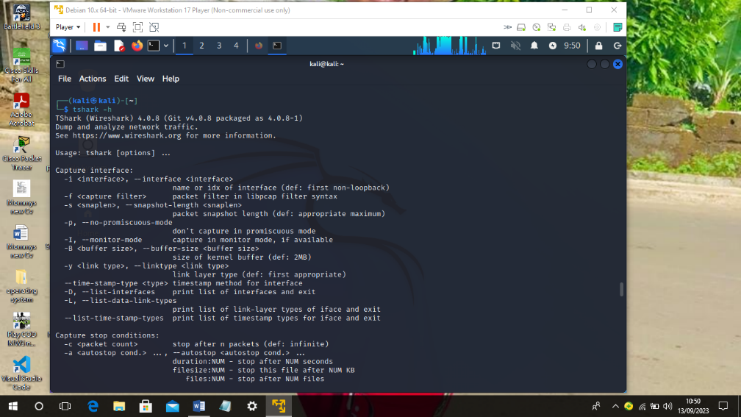

### 

### 

### **TCPDUMP**

### **Tcpdump**

Tcpdump is a network capture and protocol analysis tool (www.tcpdump.org). This program is based on the libpcap interface, a portable system-independent interface for user-level network datagram capture. Despite the name, tcpdump can also be used to capture non-TCP traffic, including UDP and ICMP. One of this tool's primary benefits is its wide availability, making it the de facto standard format for captured network traffic. The tcpdump program ships with many distributions of BSD, Linux, and Mac OS X, and there is a version that can be installed on Windows systems.

tcpdump is a packet analyzer that is launched from the command line. It can be used to analyze network traffic by intercepting and displaying packets that are being created or received by the computer it’s running on. It runs on Linux and most UNIX-type operating systems. In order to install the tcpdump package, obtain or locate the appropriate package file for your distribution. Different distributions may have packages specific to their configuration, or a given distribution may not support the newest version of a piece of software. Then enter the following command to install tcpdump (for this example it is version 3.9.4–1):

rpm –i tcpdump–3.9.4–1.i586.rpm

If the installation is successful, you should see output similar to the following:

Preparing… ########################################### [100%]

1: tcpdump-3.9.4-1 ########################################### [100%]

# **How to Install tcpdump**

Tcpdump is a powerful command-line packet analyzer tool used to capture and analyze network traffic in real-time. It is an essential tool for network administrators, security professionals, and developers who need to monitor and troubleshoot network issues.

In this guide, we will show you how to install tcpdump on various operating systems.

## Install tcpdump on Ubuntu or Debian-based Systems

To install tcpdump on Ubuntu or Debian-based systems, you can use the following command:

sudo apt-get update && sudo apt-get install tcpdump

This command will update the package manager and install tcpdump.

## Install tcpdump on Red Hat-based Systems

To install tcpdump on Red Hat-based systems, you can use the following command:

sudo yum install tcpdump

This command will install tcpdump on your system.

## Install tcpdump on macOS

To install tcpdump on macOS, you can use the following command:

brew install tcpdump

This command will install tcpdump using the Homebrew package manager.

## Install tcpdump on Windows

To install tcpdump on Windows, you will need to install the Windows Subsystem for Linux (WSL). Follow these steps to install tcpdump:

Install WSL by following the instructions on the Microsoft website.  
Once WSL is installed, launch the Ubuntu terminal and run the following command to update the package manager:

sudo apt-get update

Run the following command to install tcpdump:

sudo apt-get install tcpdump

This command will install tcpdump on your system.

## Usage in Linux

### Show available interface that can be monitor :

# tcpdump -D

1.eth0

2.usbmon1 (USB bus number 1)

3.usbmon2 (USB bus number 2)

4.any (Pseudo-device that captures on all interfaces)

5.lo

### Check tcpdump version in CentOS 6.7

# tcpdump --version

tcpdump version 4.1-PRE-CVS_2015_07_23

libpcap version 1.4.0

Usage: tcpdump [-aAdDefhIJKlLnNOpqRStuUvxX] [ -B size ] [ -c count ]

[ -C file_size ] [ -E algo:secret ] [ -F file ] [ -G seconds ]

[ -i interface ] [ -j tstamptype ] [ -M secret ]

[ -P in|out|inout ]

[ -r file ] [ -s snaplen ] [ -T type ] [ -w file ]

[ -W filecount ] [ -y datalinktype ] [ -z command ]

[ -Z user ] [ expression ]

### Check tcpdump version in CentOS 7.1

# tcpdump --version

tcpdump: invalid option -- '-'

tcpdump version 4.5.1

libpcap version 1.5.3

Usage: tcpdump [-aAbdDefhHIJKlLnNOpqRStuUvxX] [ -B size ] [ -c count ]

[ -C file_size ] [ -E algo:secret ] [ -F file ] [ -G seconds ]

[ -i interface ] [ -j tstamptype ] [ -M secret ]

[ -P in|out|inout ]

[ -r file ] [ -s snaplen ] [ -T type ] [ -V file ] [ -w file ]

[ -W filecount ] [ -y datalinktype ] [ -z command ]

[ -Z user ] [ expression ]

## Commands Mentioned:

* apt-get – command to install, update, and remove software packages on Ubuntu or Debian-based systems.
* yum – command to install, update, and remove software packages on Red Hat-based systems.
* brew – command to install and manage packages on macOS.
* sudo – command to run commands with administrator privileges.
* 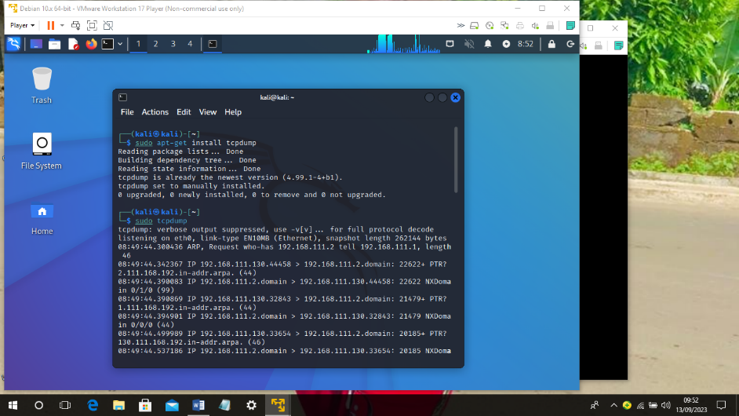apt-get update – command to update the package manager on Ubuntu or Debian-based systems.

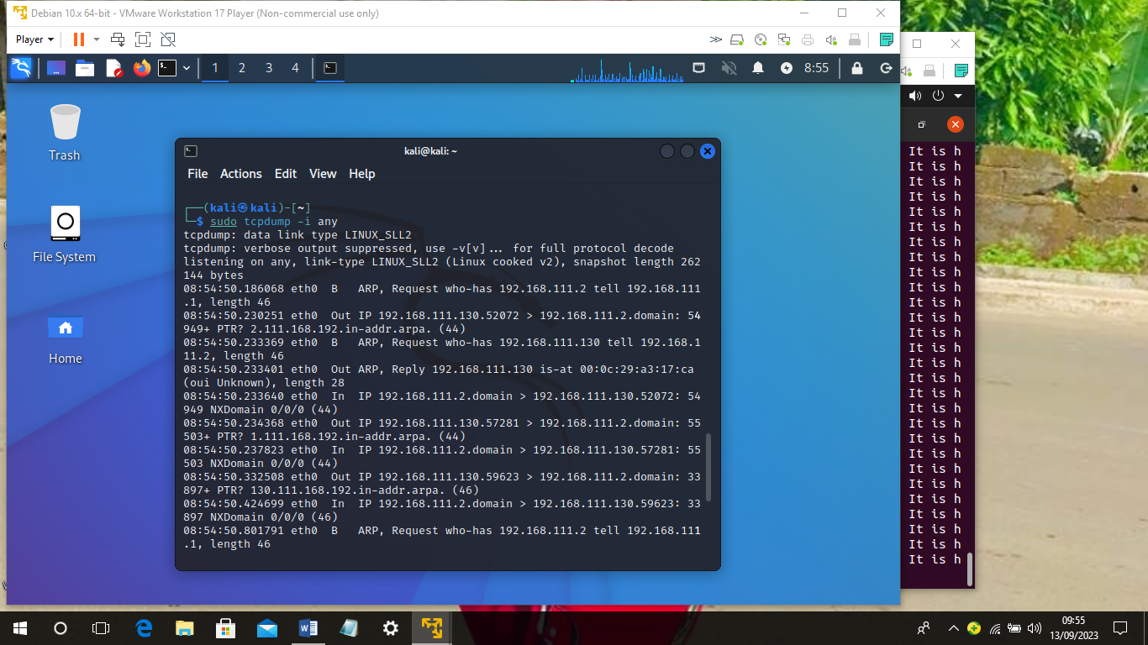

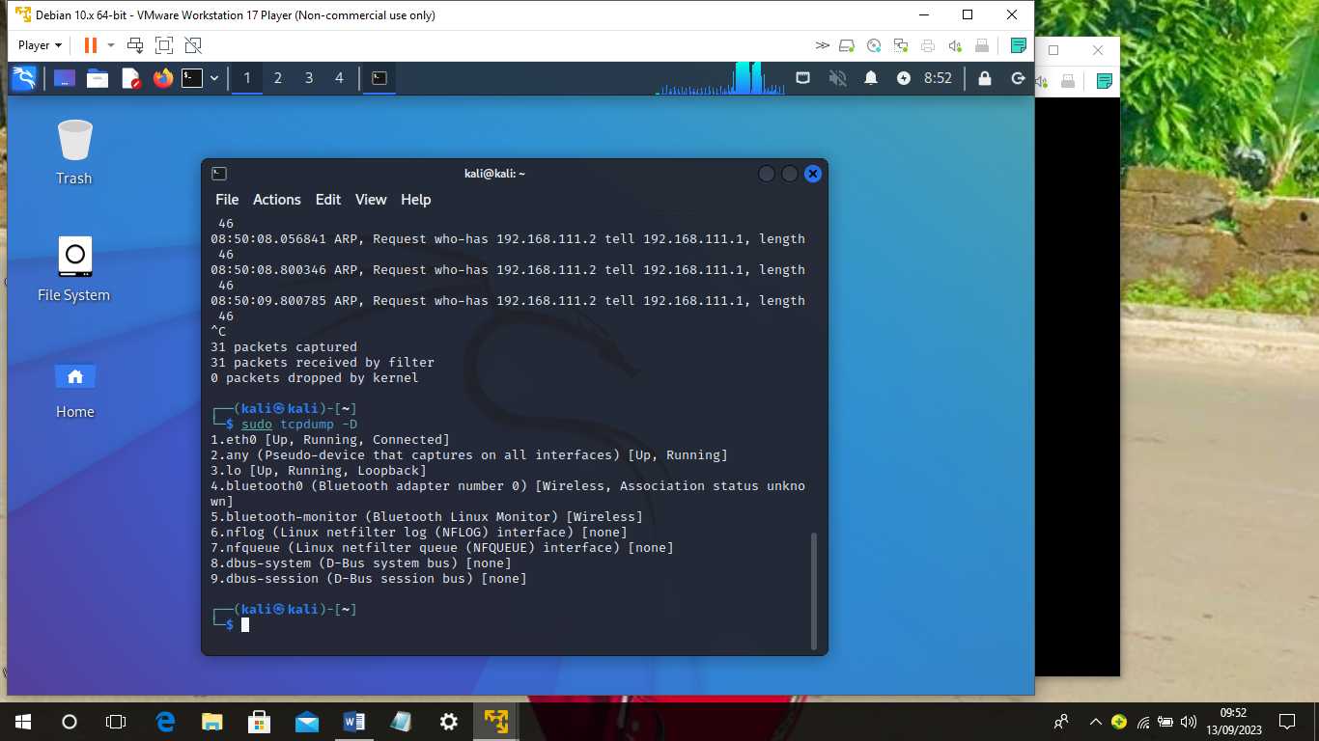

### **NETWORK MINER( NETMINER)**

## ****What is Network Miner?****

Network miner is a network forensic analysis tool (NFAT) that is available in[professional](https://www.netresec.com/?page=BuyNetworkMiner) and free versions. It is an open-source tool that helps extract artifacts from a PCAP file that is already captured. Network Miner can extract files, images, credentials, emails etc., from a pcap file which is easier for visualization and analysis. It also contains a host inventory where each IP’s present in the pcap along with OS and what communication is happening between which device, open sessions etc. It is released by [Netresec](https://www.netresec.com/?page=NetworkMiner)an independent software vendor specializing in network products, in 2007 and is widely used all around the world by incident responders and law enforcement teams. NetworkMiner is a versatile and powerful network forensics tool that provides essential features for capturing, analyzing, and investigating network traffic. Its passive operation, support for various protocols, and user-friendly interface make it an attractive option for cybersecurity professionals and network administrators alike. Key features of NetworkMiner include:

1. **Passive network sniffing:** NetworkMiner operates in a passive mode, meaning it does not interfere with network traffic or send any data packets onto the network. This makes it an unobtrusive and stealthy tool for network analysis.
2. **Protocol parsing:** NetworkMiner can parse a variety of network protocols, including HTTP, FTP, SMB, SMTP, DNS, and SSL/TLS. This allows it to extract valuable information from network traffic and provide insight into the types of data being transmitted.
3. **File and data extraction:** NetworkMiner can automatically reassemble and extract files and data transmitted over the network. This includes images, documents, and even user credentials, which can be useful for analyzing network activity and identifying potential security risks.
4. **Host and service identification**: NetworkMiner can identify hosts (devices) and services running on a network by analyzing the captured network traffic. It can also display information about the operating systems, hostnames, and open ports for each device.
5. **GeoIP location:** NetworkMiner can determine the geographical location of IP addresses based on GeoIP databases, providing a visual representation of the locations of network hosts.
6. **Offline analysis:** NetworkMiner can analyze pre-captured network traffic stored in PCAP files, which enables investigators to perform offline analysis and review historical network data.
7. **User-friendly interface:** NetworkMiner features a user-friendly graphical interface that organizes captured data into easily navigable tabs, making it straightforward to use for both beginners and experienced professionals.

**How to Install Network Miner?**

Network Miner is primarily designed for windows, but it is also available for Linux users too. We got you covered the installation of Network Miner on both Windows and Linux platforms. Let’s see how to install Network Miner on Linux, followed by Windows.

### How to Install Network Miner on Linux?

The Network Miner installation process is simple and straight. You need to run this command on your Linux distributions. Make sure you run the command on the correct distribution.

[**Ubuntu**](https://thesecmaster.com/introduction-to-ubuntu/) (also other Debian-based distros like Xubuntu and Kali Linux)

***sudo apt install mono-devel***

**Install NetworkMiner**

*wget https://www.netresec.com/?download=NetworkMiner -O /tmp/nm.zip  
sudo unzip /tmp/nm.zip -d /opt/  
cd /opt/NetworkMiner*  
sudo chmod +x NetworkMiner.exe  
sudo chmod -R go+w AssembledFiles/  
sudo chmod -R go+w Captures/*

